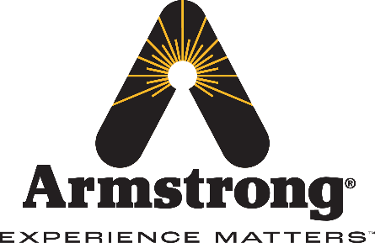
Armstrong International Acquires Majority Interest in WARE Inc.
Leading global thermal utility solutions provider adds WARE Inc. to family of companies, bolstering steam, hot water generation & service capabilities
THREE RIVERS, MICH. [MONTH, DATE, YEAR] —Armstrong International, a global leader in efficient thermal utility solutions, today announced the acquisition of Louisville, Ky.-based WARE Inc., one of the nation’s largest industrial and commercial boiler and hot water rental and service companies. The combination of the two highly respected family-owned organizations will bring immediate benefits and long-term opportunities for both companies, their customers and collective workforce.
“Armstrong International values experience and a commitment to customer service. Both are qualities WARE has brought to the industrial boiler space for the past seven decades,” said Armstrong International CEO Kurt Armstrong. “In our journey to optimize industrial energy use we had identified the need for a partner like WARE, with deep industry capabilities and a truly complementary culture. We believe this partnership will enhance our capabilities across the board.”
By adding WARE, Armstrong’s North American operations will expand to offer boiler and hot water generation rental, service, training and installation. Current WARE customers will benefit from Armstrong’s thermal utility expertise and global reach.
Existing partners and vendors will not see any changes in their respective relationships with Armstrong or WARE. The companies are working together to ensure a smooth transition and continuity in pricing/billing, with new product and service opportunities on the horizon.
“We are very proud of the foundation we have built at WARE, and we know Armstrong is the right company at the right time to help build on that foundation,” said Ritchie Ware. “We look forward to joining Armstrong and to all it will bring our organization and our customers.”
“One of the most exciting aspects of this investment is that both Armstrong and WARE share common values as multi-generational, family owned and operated organizations. I believe our cultures will mesh very well, and we look forward to building something great together,” Armstrong continued.
To learn more about Armstrong International, please visit: armstronginternational.com
To learn more about WARE Inc, please visit: www.wareinc.com
###
ABOUT ARMSTRONG INTERNATIONAL:
Armstrong International provides intelligent system solutions that improve utility performance, lower energy consumption, and reduce environmental emissions. As the industry’s leading thermal utility partner, Armstrong International can satisfy unique requirements while helping to improve efficiency and reduce energy consumption and emissions. The fifth-generation, family-owned business provides hardworking products, state-of-the-art technology, custom-engineered systems, and services, and more than a century of knowledge and experience — all organized with industry specificity. Founded in 1900, Armstrong International is headquartered in the United States, with manufacturing, sales and seminar centers located throughout the Americas, EMEA and Asia. For more information, visit armstronginternational.com.
Media contact:
Megan Wolowiec
Lambert
mwolowiec@lambert.com

